CSE 333 - OPERATING SYSTEMS

Programming Assignment # 1 Report

**1-) myprog1.sh**

# Shell script to test if a string is a palindrome. We control input is entered or not. Then we compare and iterate the first character of the string is the same with the last character of the string by while loop.

Error control:

##control input is entered or not

##control head of string is equal to end of string or not

##control number of entered arguments

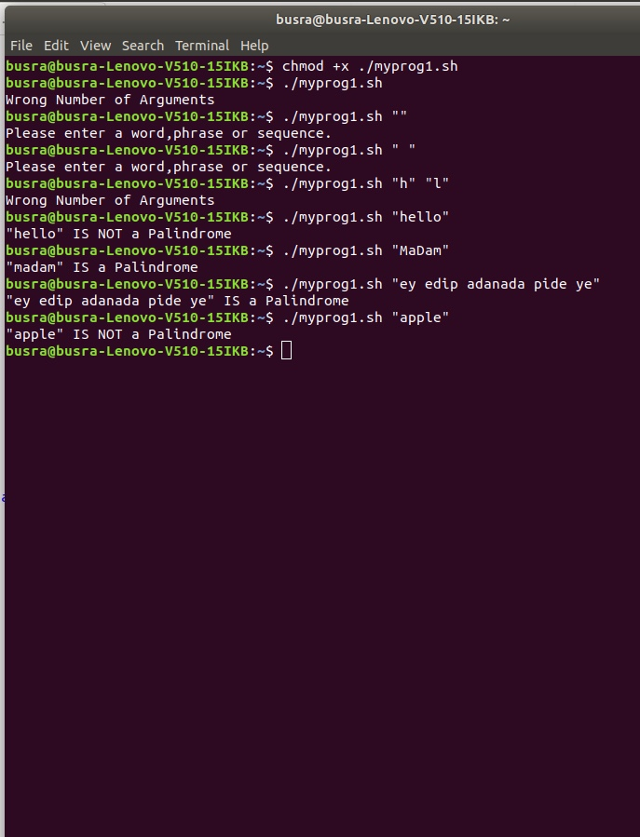

**2-) myprog2.sh**

#Shell script takes an optional pathname as a parameter. If your program is run with no parameters, it will create a directory named cprogs under the current working directory and move all of the files whose name ends with .c to this directory. If your program is run with an argument, it will create a directory name cprogs under the given path and move all of the files whose name ends with .c under the given path to this directory.

The following screenshots are about no argument run.

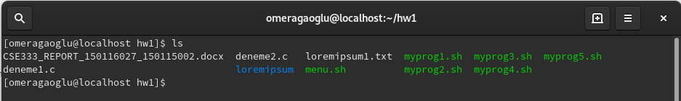

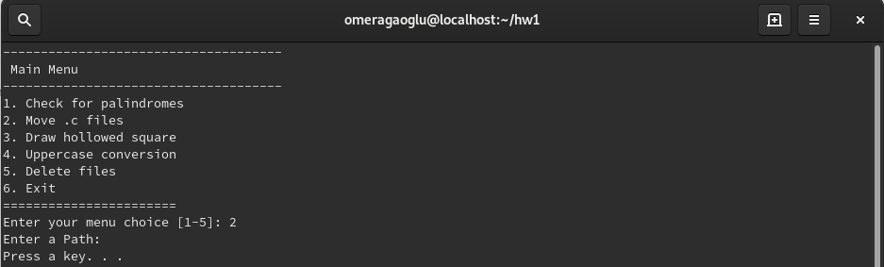

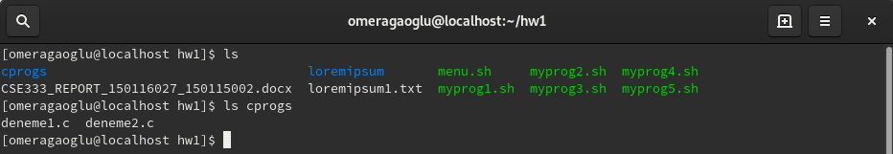

The following screenshots are about argument run.

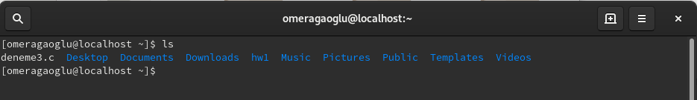

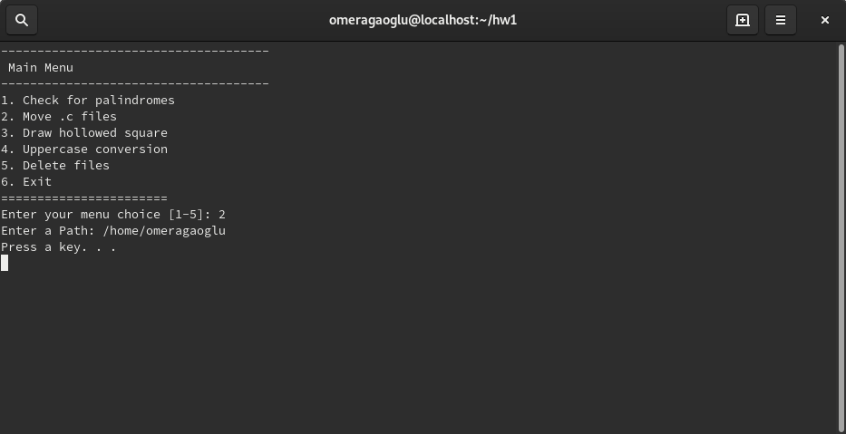

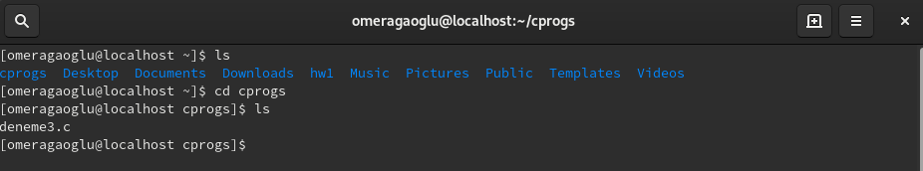

Error control:

## pathname is empty or not

##pathname is valid or not

## cprogs folder is exist or not

**3-) myprog3.sh**

# We have inputs and then control inputs are an integer or not. If first input bigger than second input and difference of these inputs is even starting the for loops. We print stars in first for a loop by the difference of inputs, print spaces by smaller input and then again print stars with the first loop.

Error control:

## control how many input is entered

##control i1 and i2 is integer or not

## control i1>i2 and difference between i1 and i2 is even or not

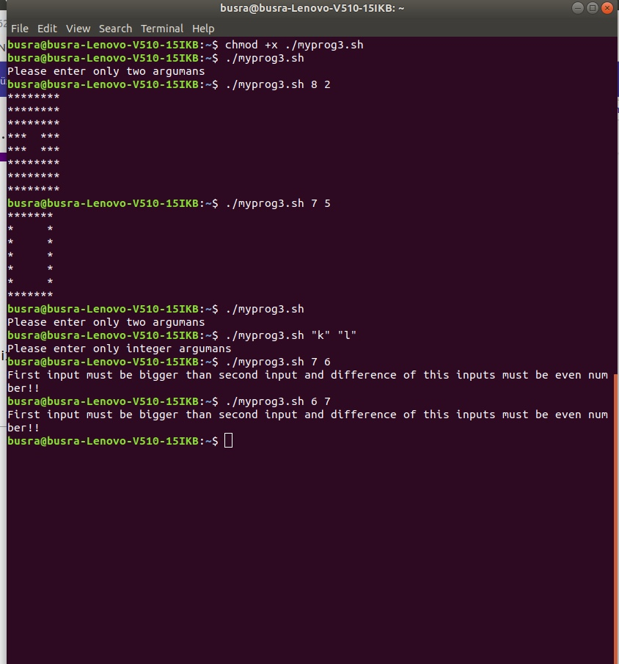

**4-) myprog4.sh**

# We take pathname and wildcard as inputs. And then the control input number is correct or not. And we find a wildcard “*” position in word by if condition and we defined an array to keep txt names that contain given wildcard. And search given wildcard in a given path by recursively. If these words assign given wildcard and they are matching uppercase this words, we change this updated uppercase words in .txt files in the pathname. If there is one input (only wildcard) taken, we repeat the same process with only one input in the current directory.

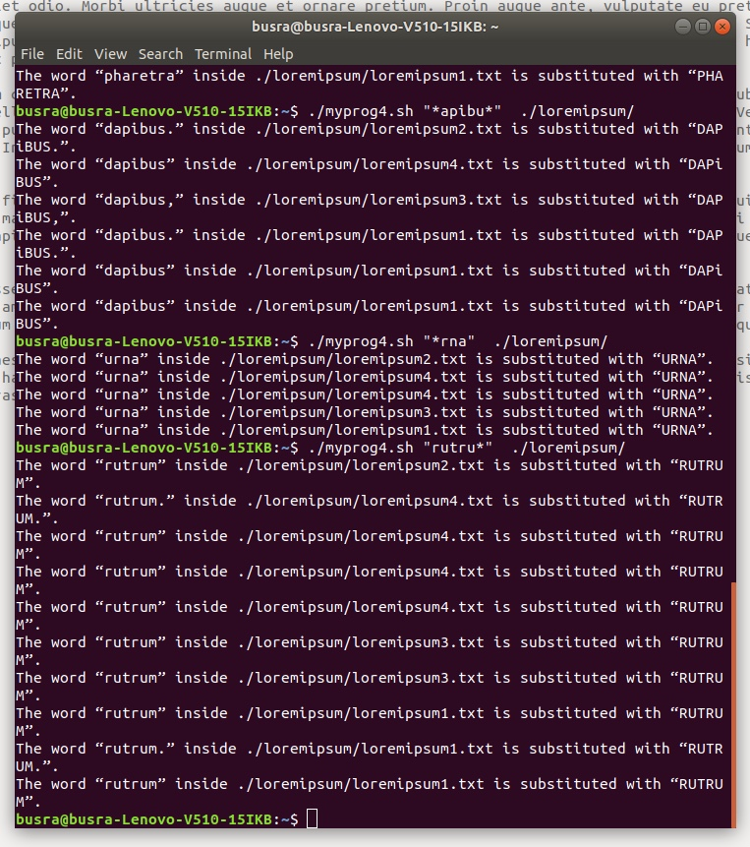

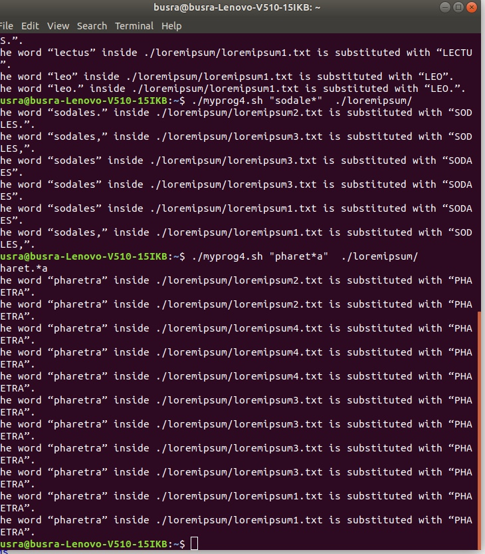

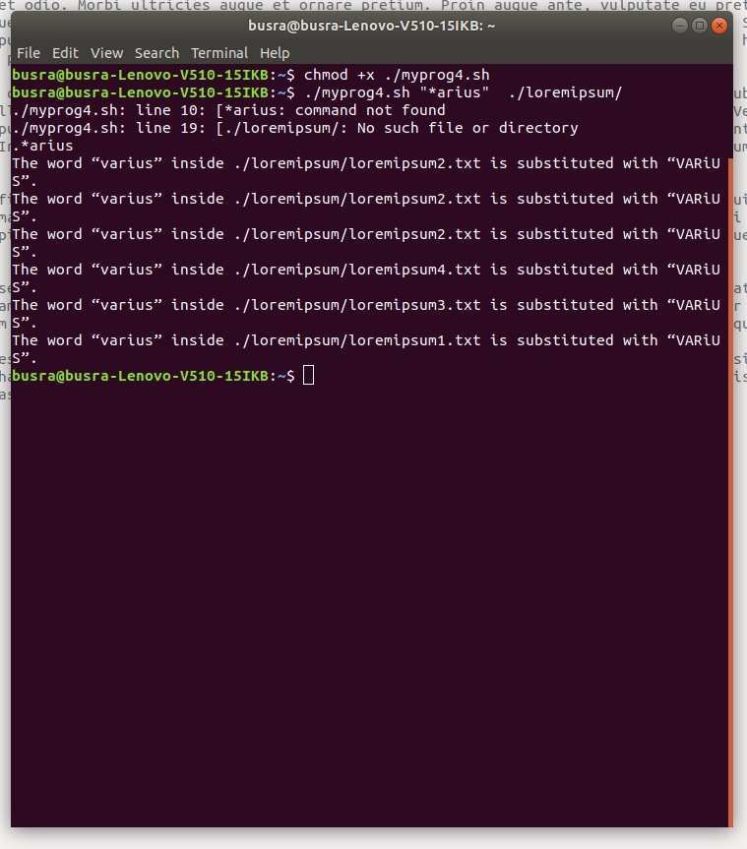

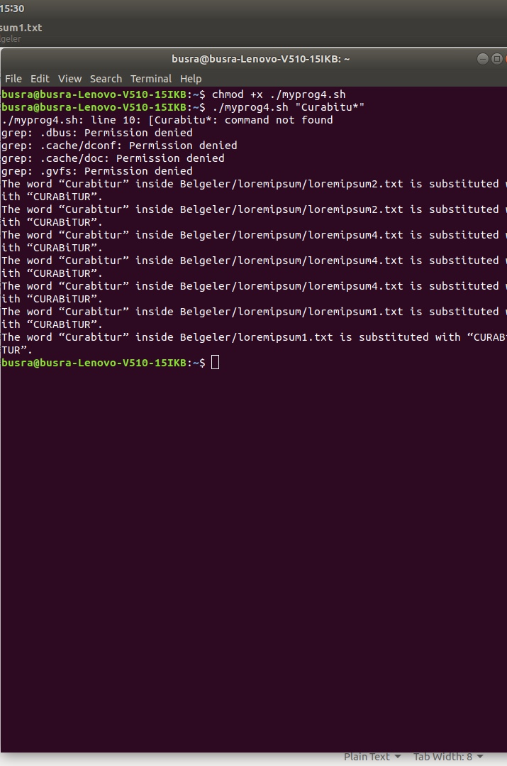

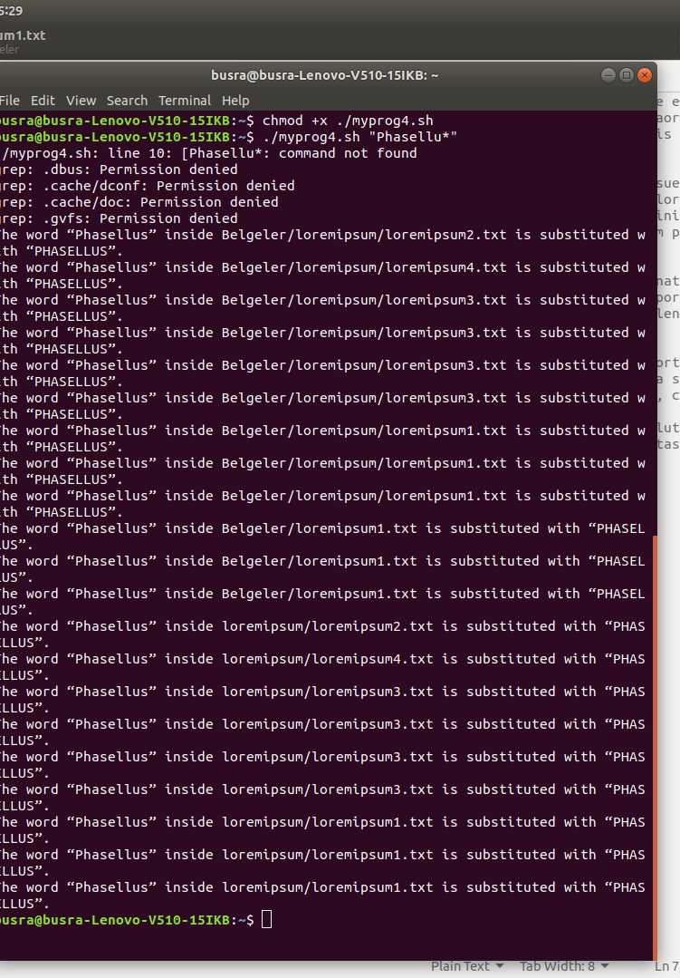

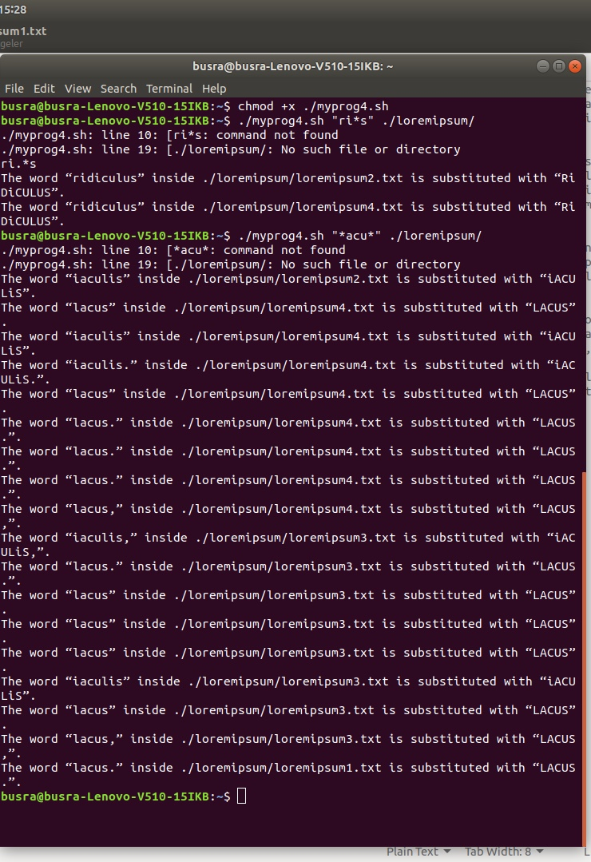

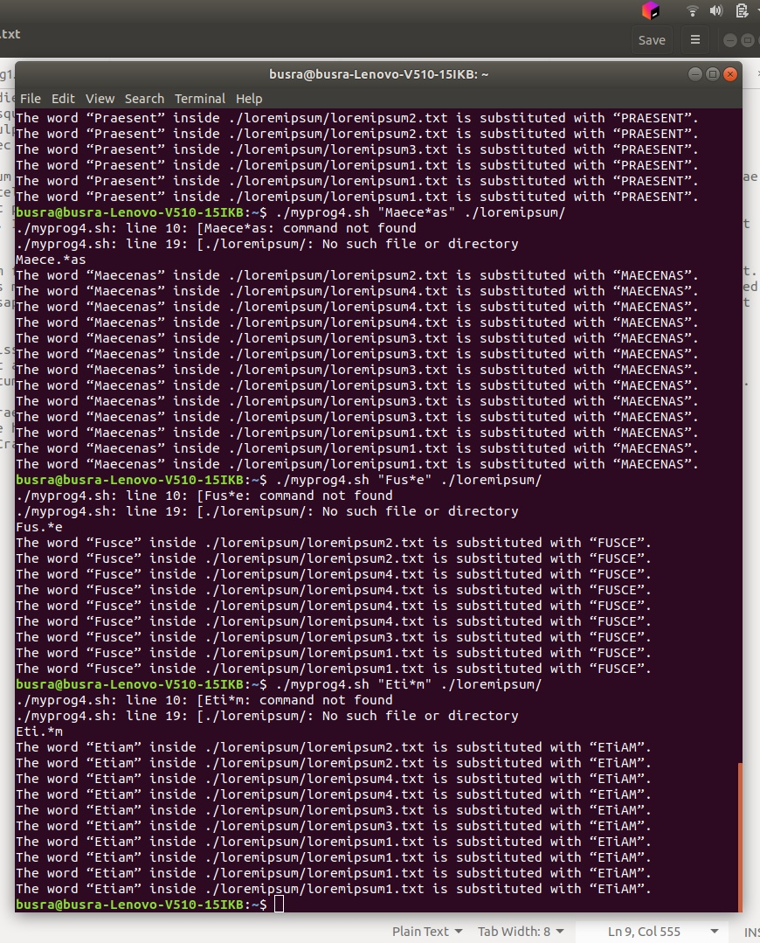

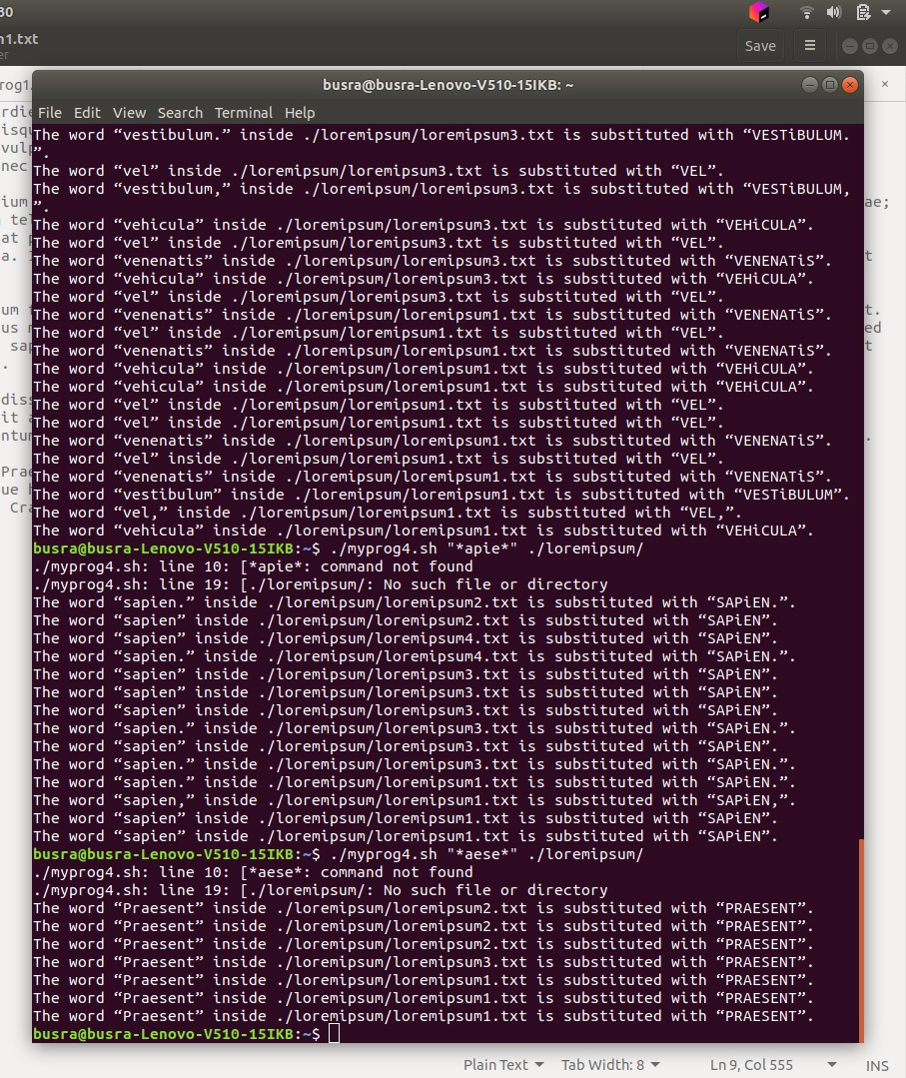

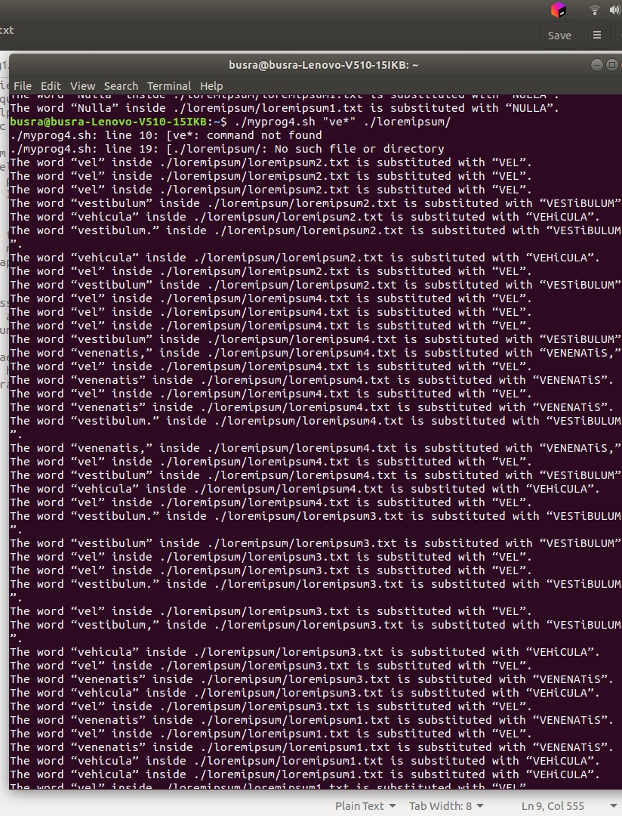

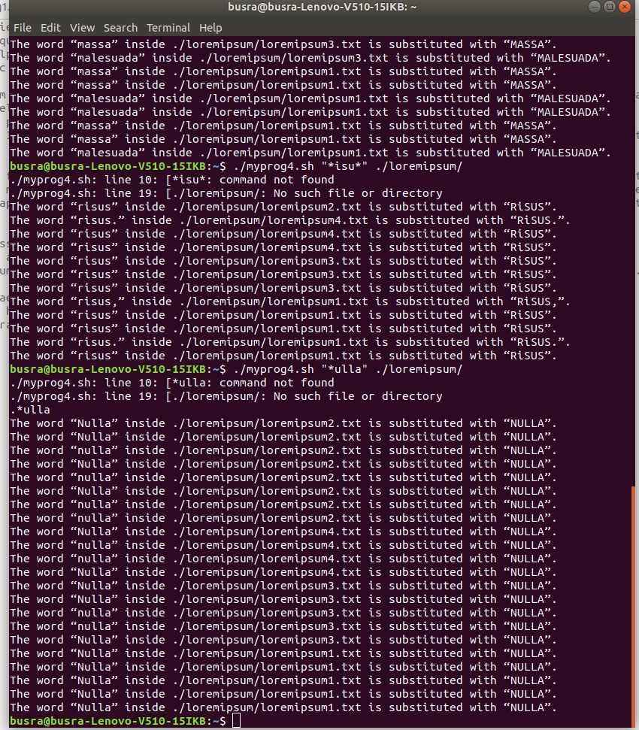

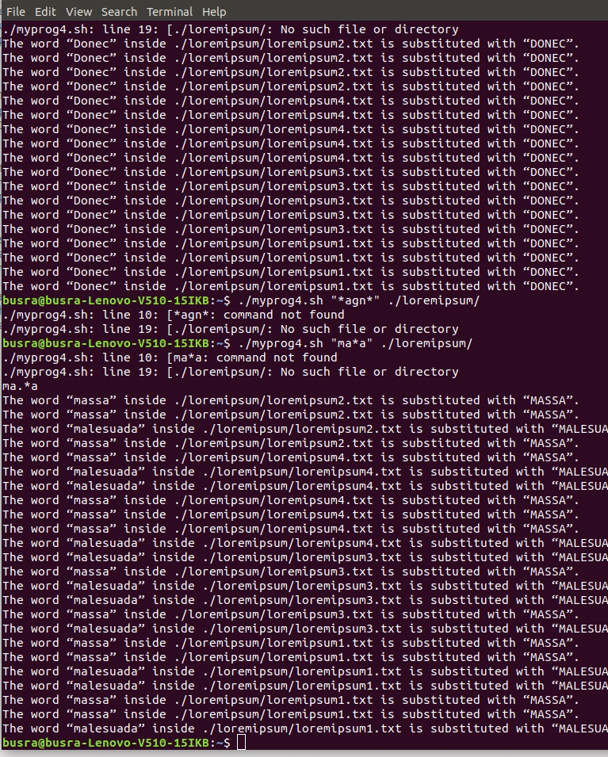

Error Control:

#Invalid input, your input must be a wildcard

# Invalid input number, please enter one or two input

#number of input

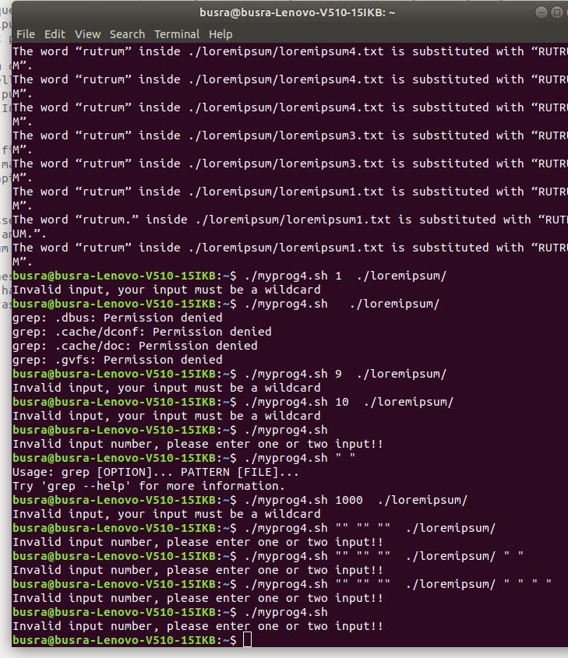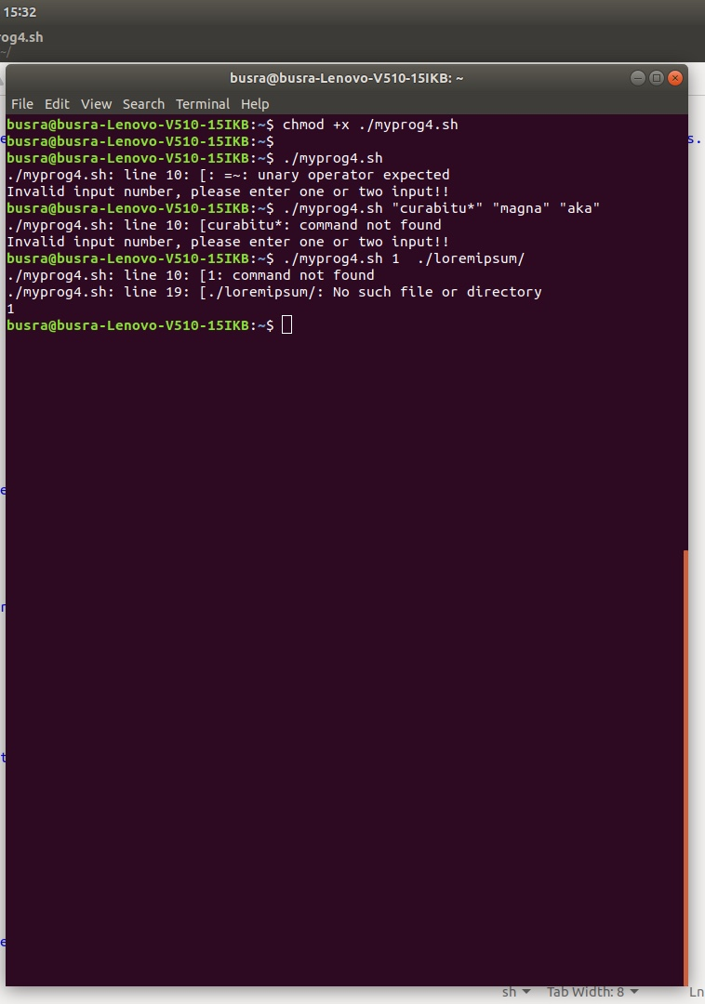

**5-) myprog5.sh**

My shell script that takes an optional pathname as an argument and a -R option. If my program is run with no arguments, then it will find all the files whose size is zero under the current working directory and ask the user to delete them one by one. If my program is run with a pathname as an argument, then it will find all the files whose size is zero under given pathname and ask the user to delete them one by one. If -R option is given, then my program will work recursively.

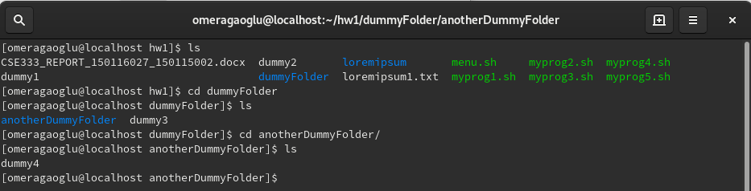

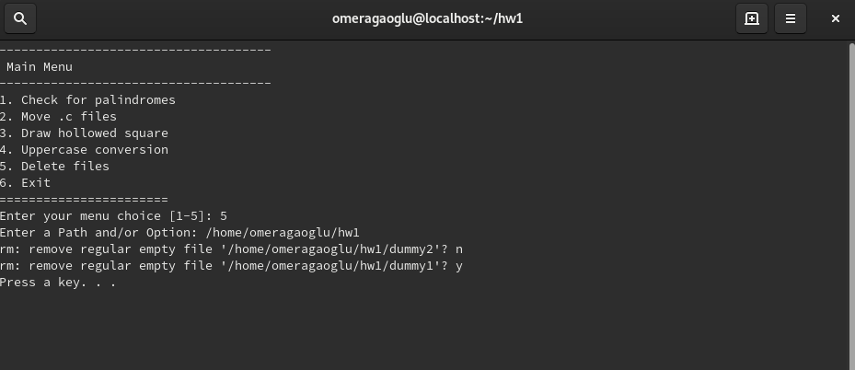

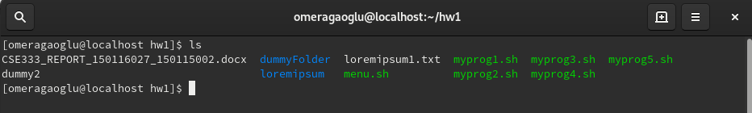

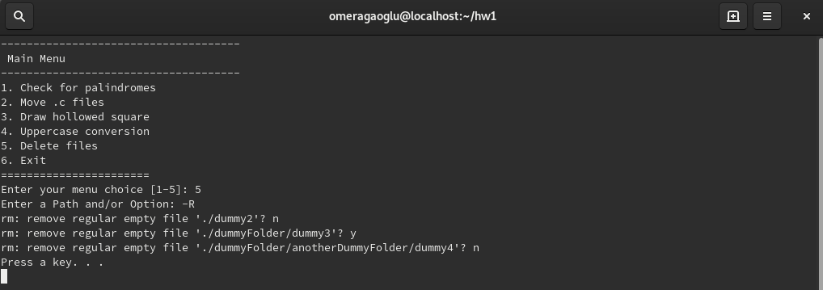

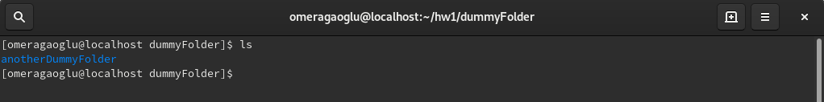

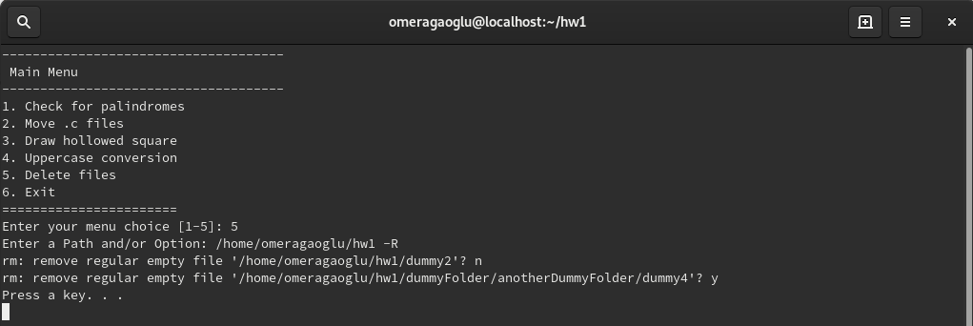

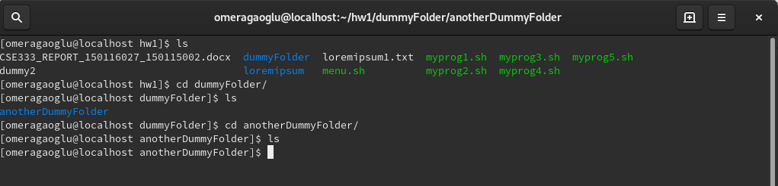

Error control:

##number of inputs

## pathname is valid or not

##option is equal to “-r”, “-R” or not

## cprogs folder exists or not

**6-) menu.sh**

Our menu works in a while loop which allows us to use the program again and again without running the menu.sh file each time. Our menu takes inputs due to questions and runs the question selected. The entered inputs are consumed by question files inside. Sample display of menu(There were many sample screenshots of menu usages above)

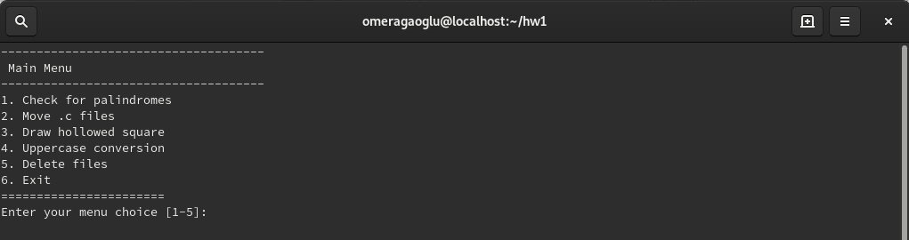

Until the user enters 6 in menu choice, the menu will keep running, otherwise, it exists.